Application Deployment
Brain App
Part 1: GIT Clone & Docker
- Cloned the repo (Brain-Tasks-App)
- Created Dockerfile (nginx:alpine serving pre-built dist/)
- Built Docker image (brain-tasks-app)
- Ran and tested container on port 3000
- Tagged and pushed image to DockerHub (abinayacould/brain-tasks-app:latest)
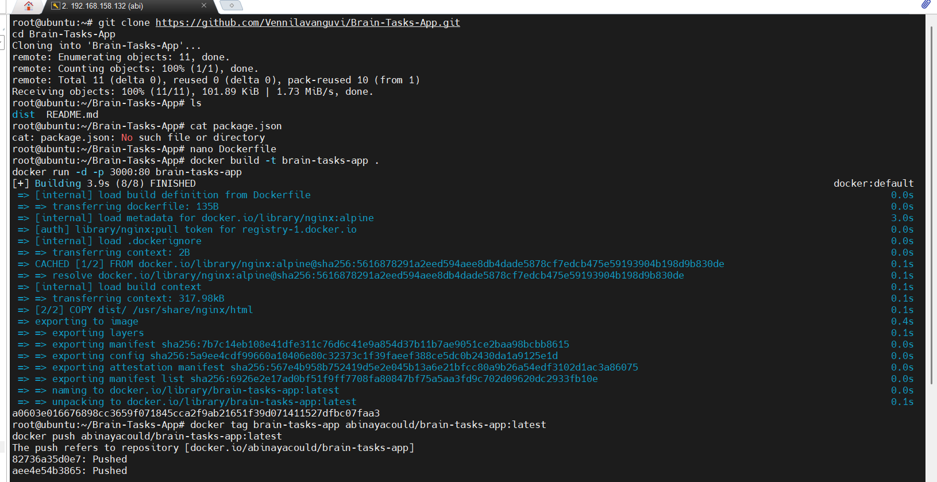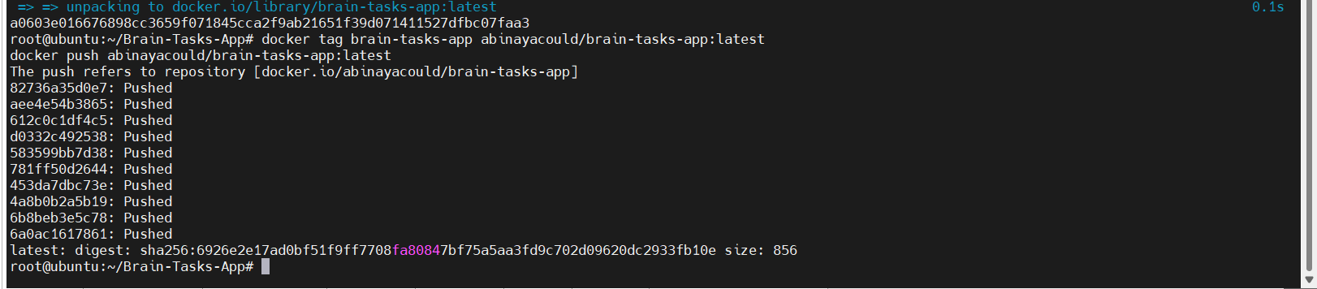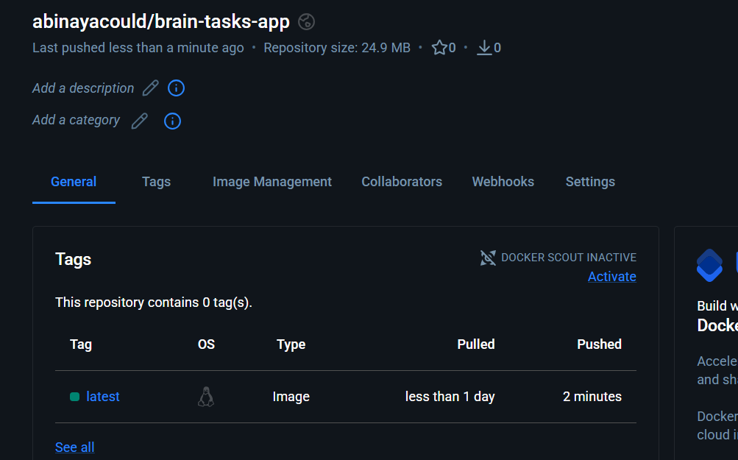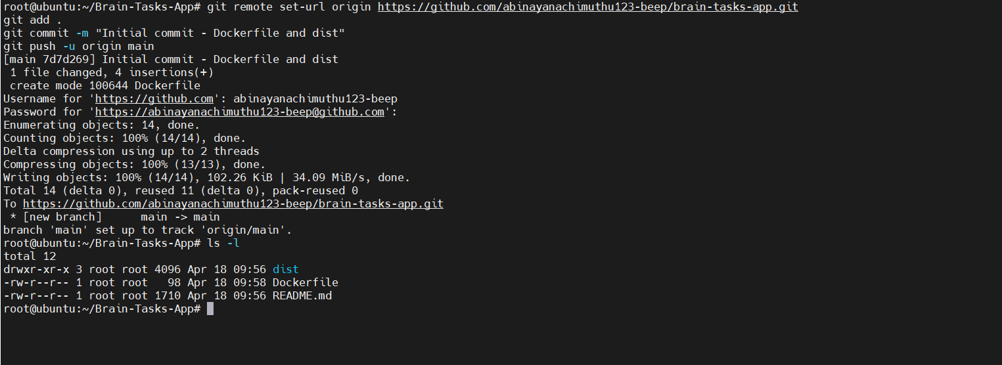
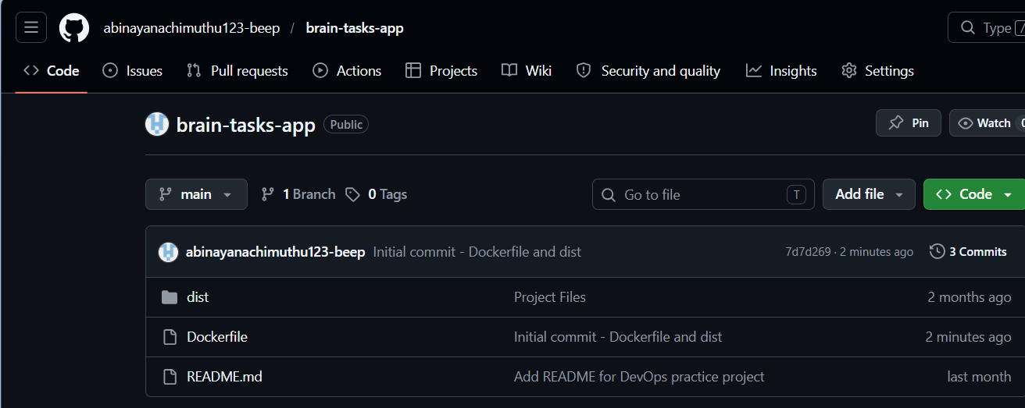
Part 2 : EKS Kubernetes
Installed eksctl and kubectl
- Created EKS cluster brain-cluster in us-west-2 with 2 nodes
- Created k8s/deployment.yaml and k8s/service.yaml
- Deployed app to EKS (kubectl apply)
- Scaled nodegroup to 4 nodes (to fix Pending pods)
- Both pods Running successfully
- LoadBalancer created and app accessible on port 3000
Verified app serving HTML via curl
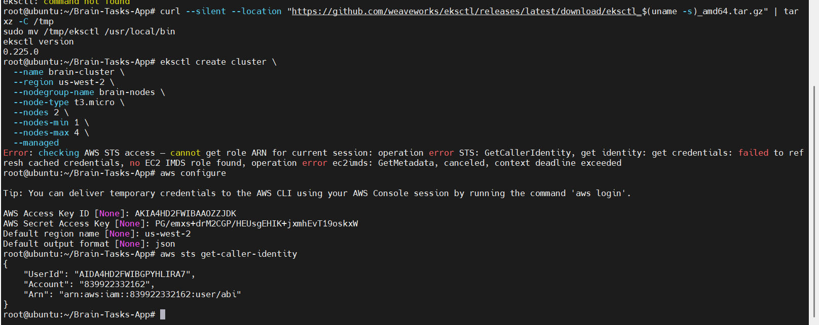
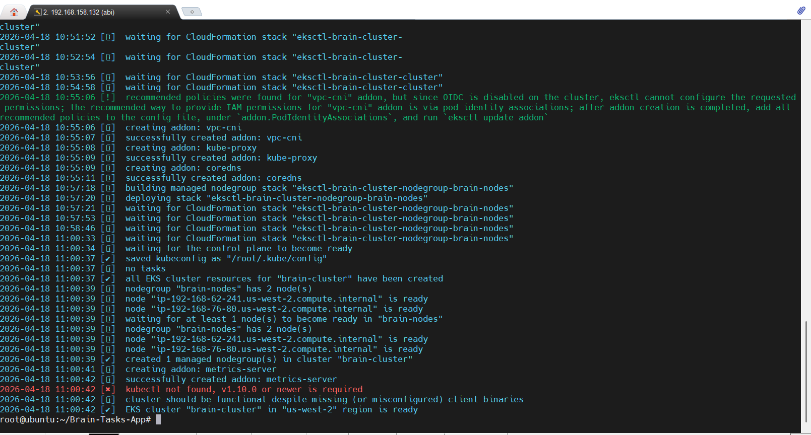
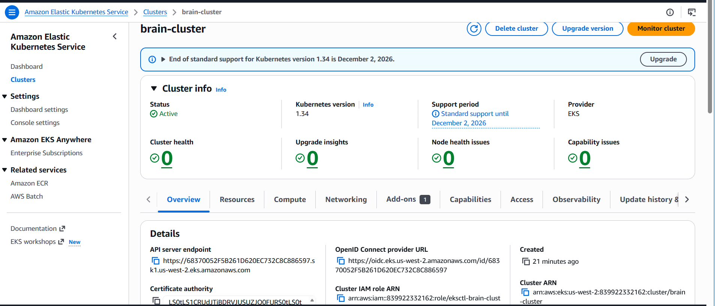
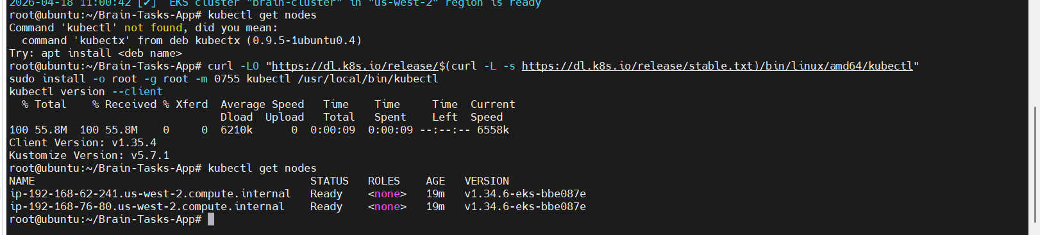
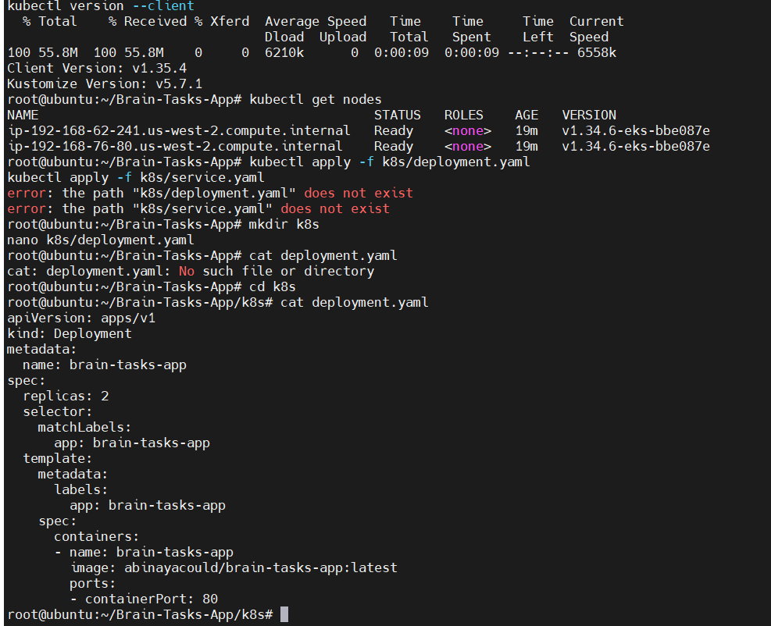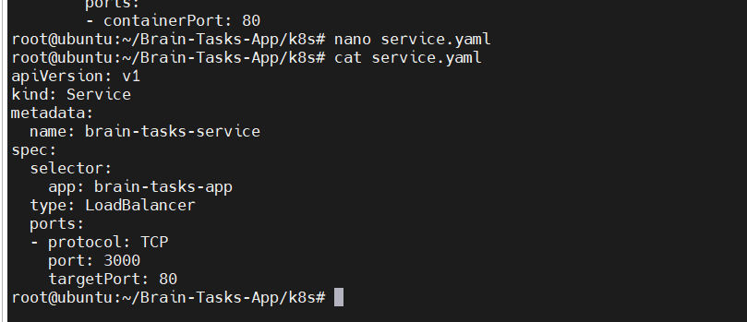
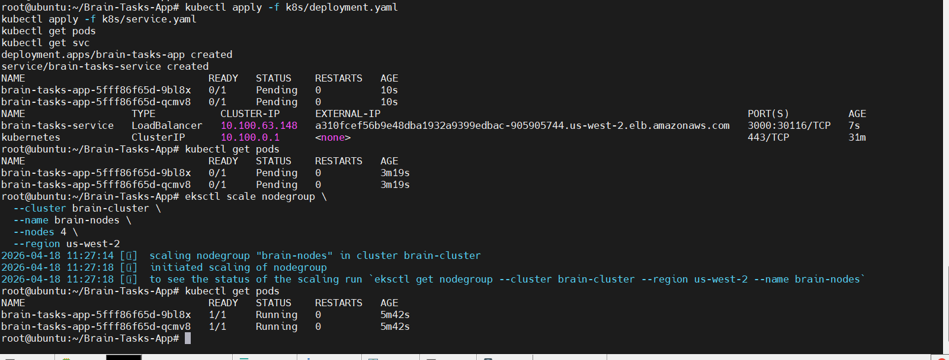
load balancer : a310fcef56b9e48dba1932a9399edbac-905905744.us-west-2.elb.amazonaws.com
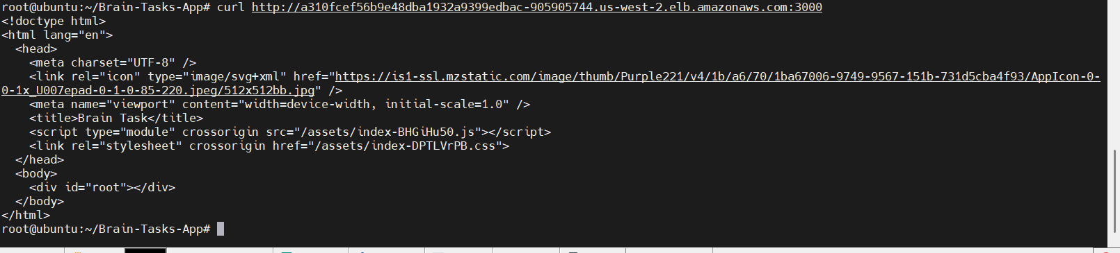
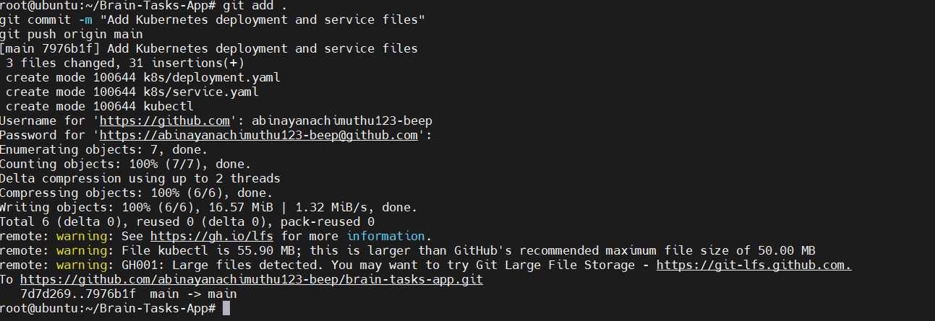
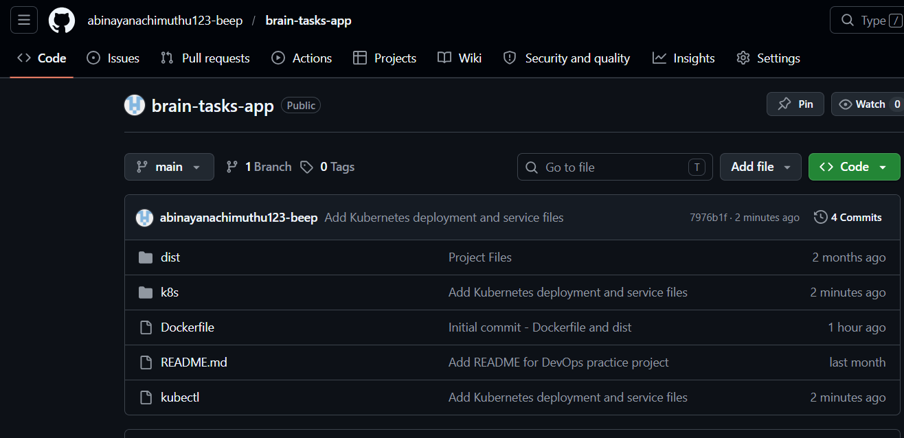
Part 3: CodeBuild Setup
Created buildspec.yml with 3 phases:
- PRE_BUILD: Docker login + EKS kubeconfig update
- BUILD: Docker image build + tag
- POST_BUILD: Push to DockerHub + kubectl deploy to EKS
- Created CodeBuild project brain-tasks-build
- Connected to GitHub repo
- Environment: Ubuntu, Standard 7.0, Privileged (Docker enabled)
- Added environment variables: DOCKERHUB_USERNAME, DOCKERHUB_PASSWORD
- CloudWatch logs enabled for build output
- Fixed IAM inline policy eks-access for EKS permissions
- Build ran successfully
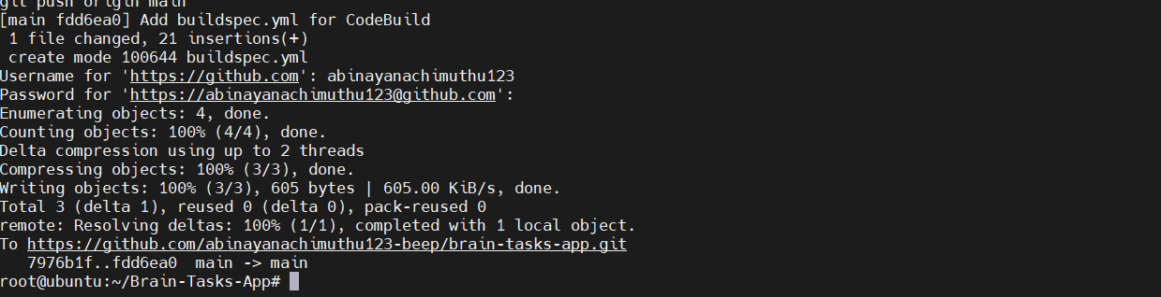
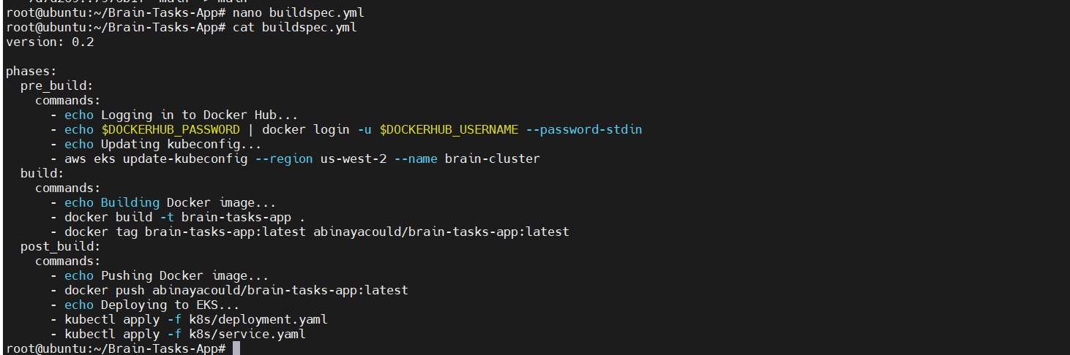
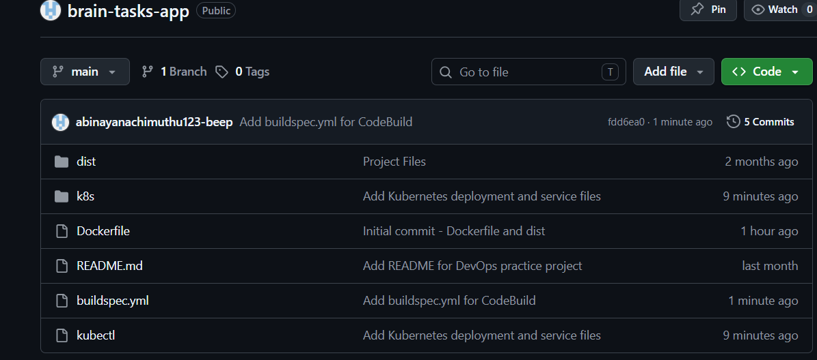
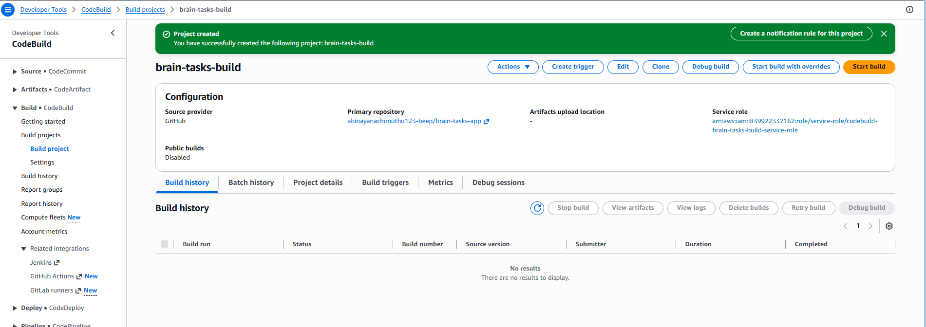
Part-4: CodePipeline
Created pipeline brain-tasks-pipeline
- Source stage: GitHub (via GitHub App) connected to brain-tasks-app repo
- Build stage: AWS CodeBuild project brain-tasks-build connected
- Pipeline auto-triggers on every GitHub push
- Fixed IAM permissions for CodeBuild to access EKS
- Fixed aws-auth configmap to allow CodeBuild to run kubectl
Pipeline ran successfully — Source ✅ → Build ✅
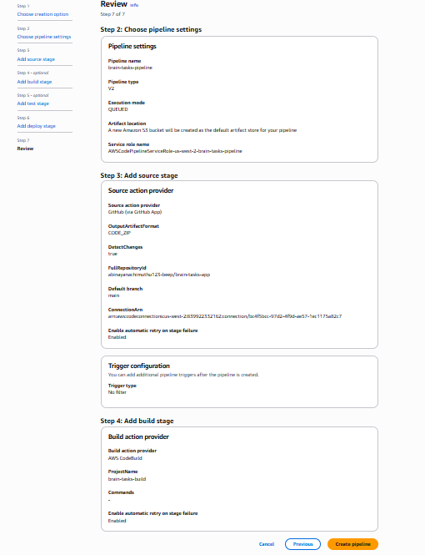
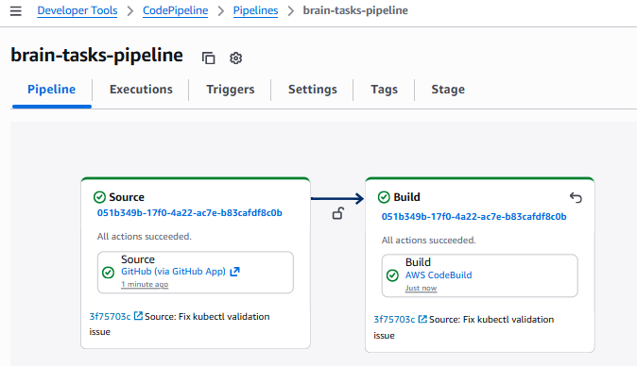
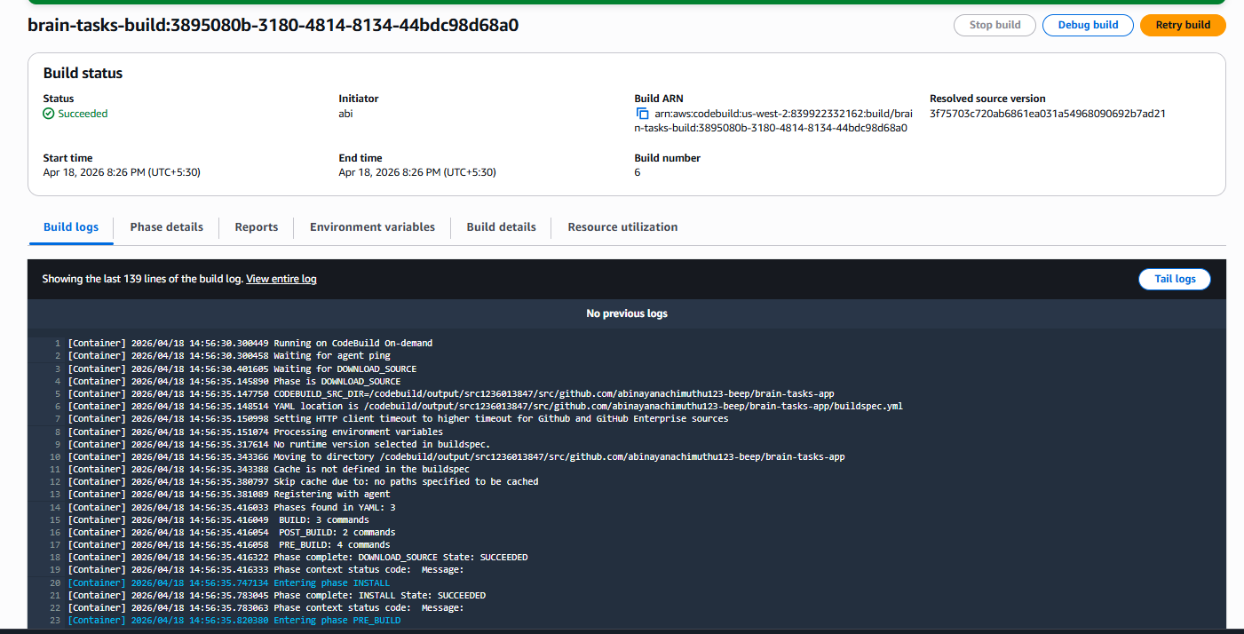
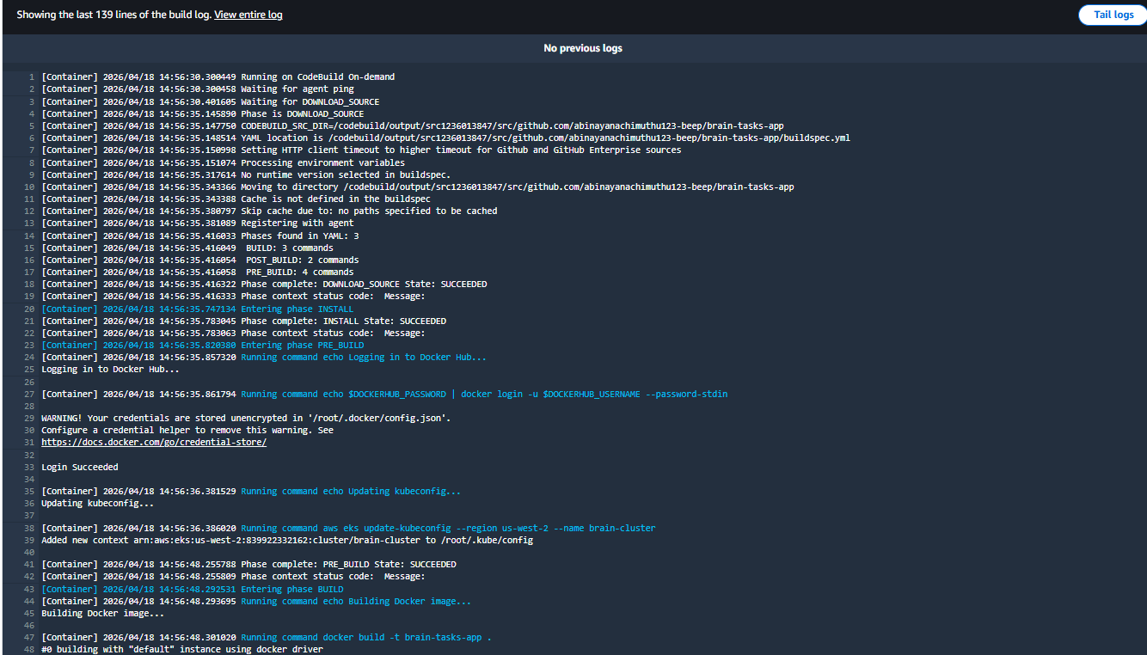
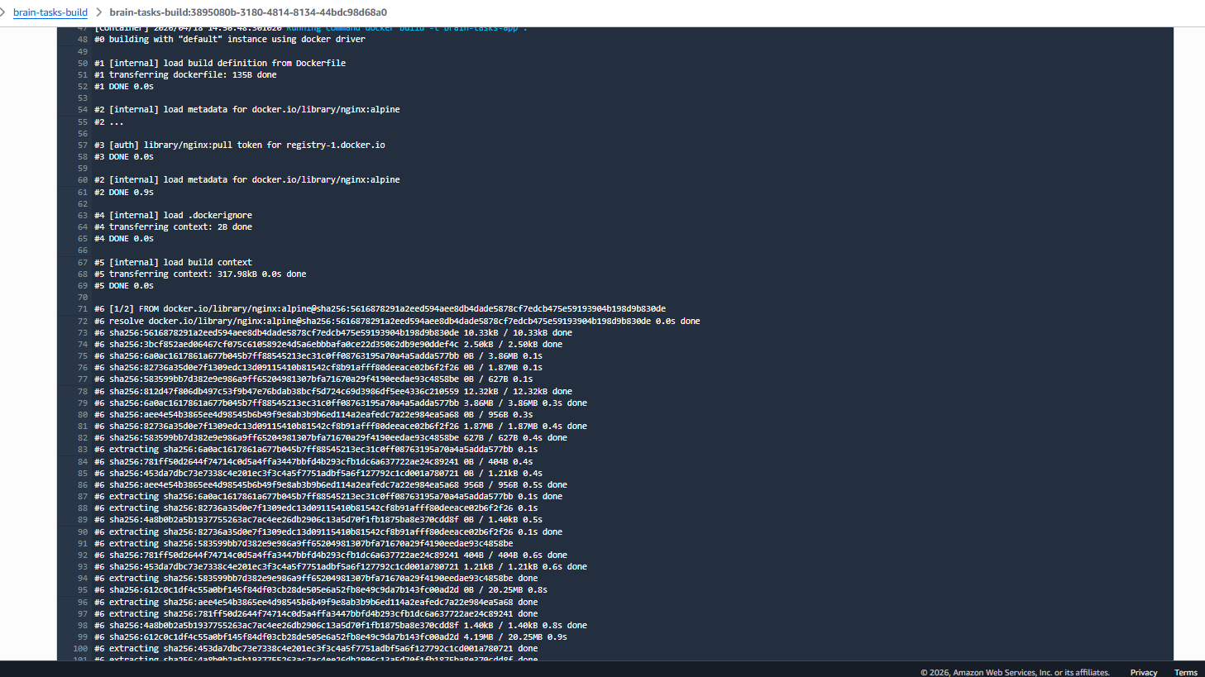
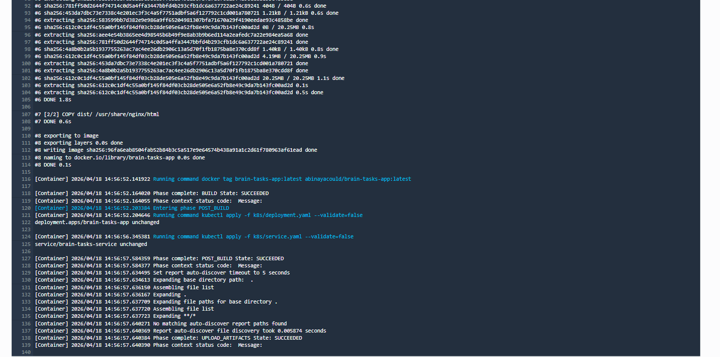
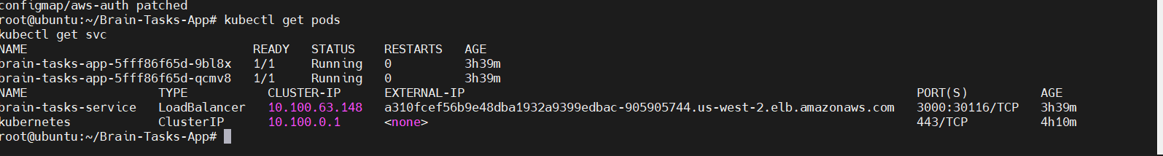
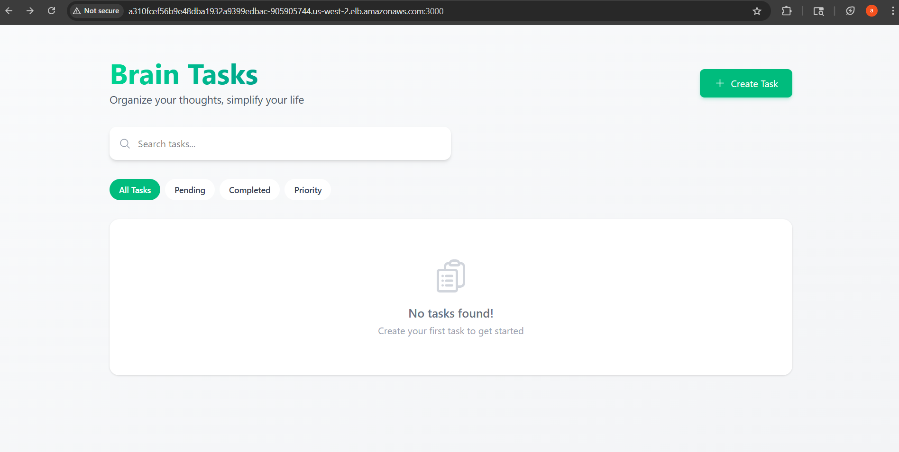
Part 5— CloudWatch Monitoring :
CodeBuild logs automatically sent to /aws/codebuild/brain-tasks-build
Installed Fluent Bit as DaemonSet on EKS cluster
Attached CloudWatchAgentServerPolicy to node IAM role
Fluent Bit running and sending logs to CloudWatch
4 log groups created:
- /aws/codebuild/brain-tasks-build — build logs
- /aws/containerinsights/brain-cluster/application — app logs
- /aws/containerinsights/brain-cluster/dataplane — kubernetes logs
- /aws/containerinsights/brain-cluster/host — node logs
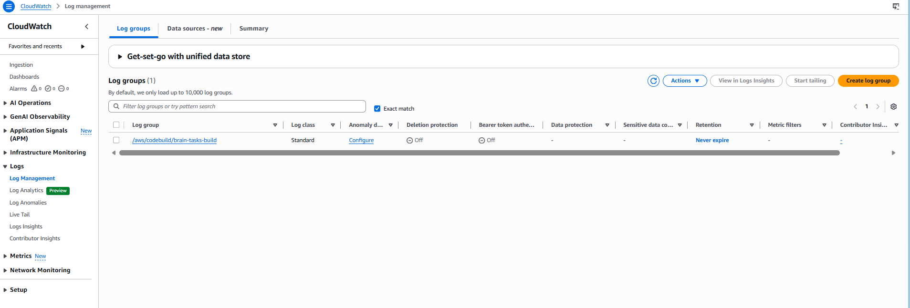
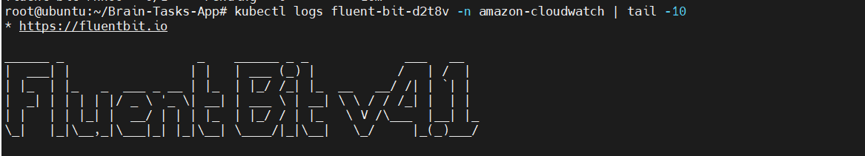
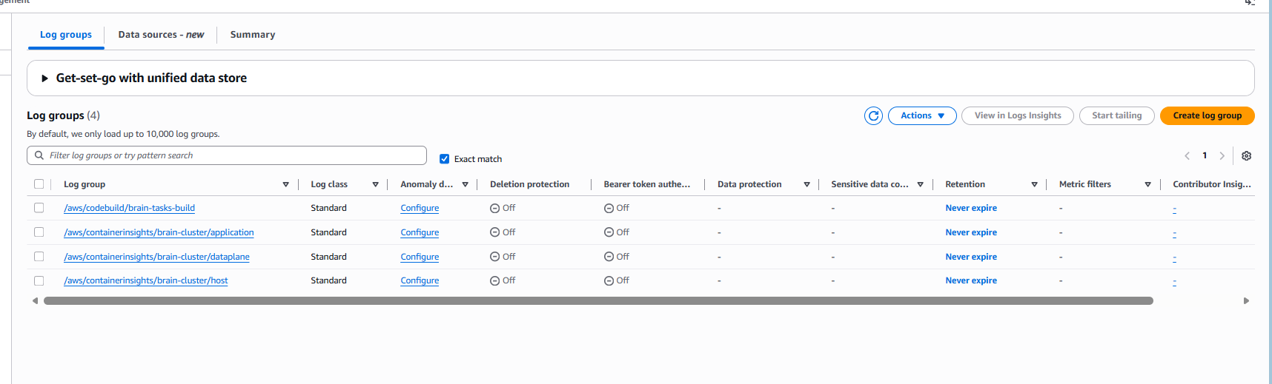
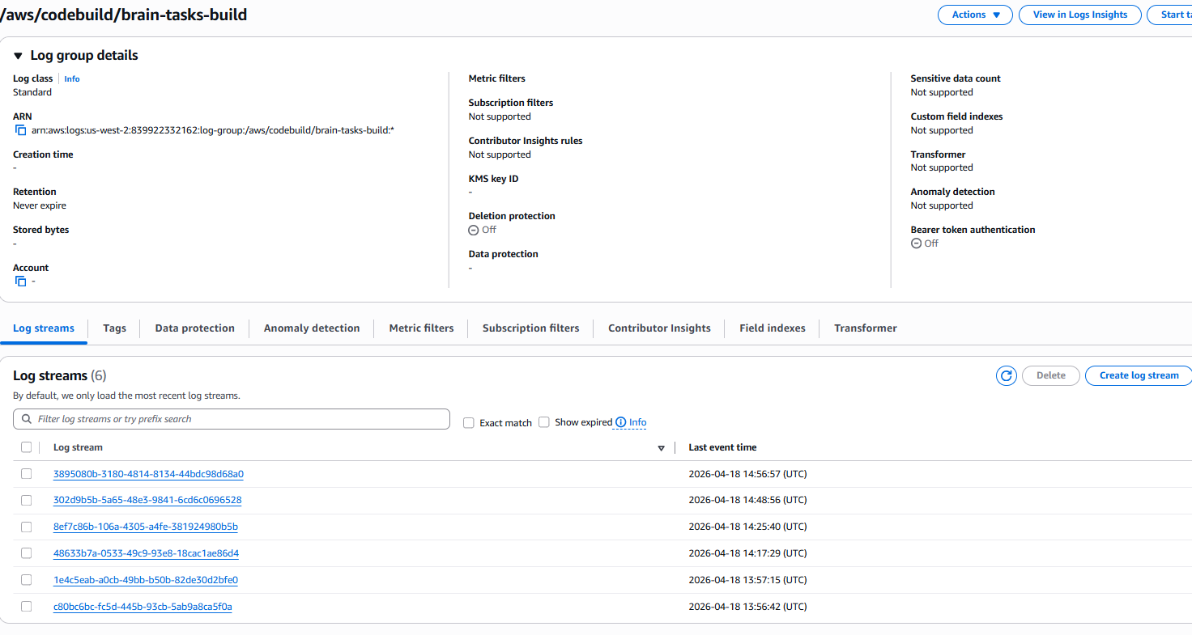
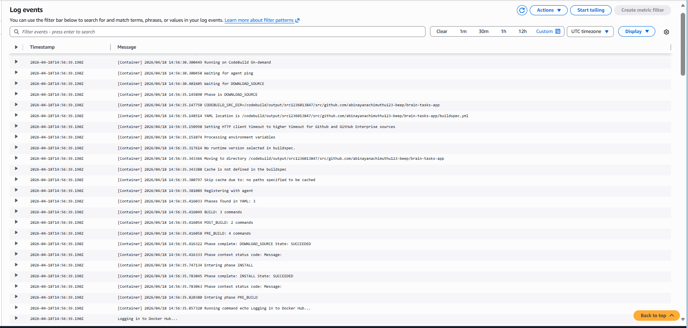
1. GitHub Repository: https://github.com/abinayanachimuthu123-beep/brain-tasks-app
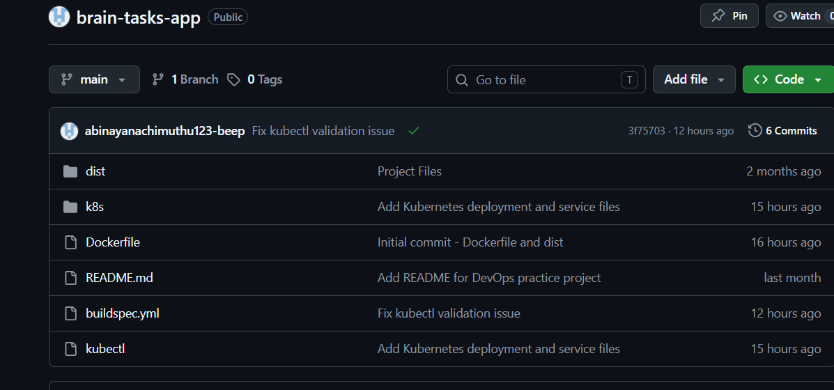
2. Kubernetes LoadBalancer ARN: a310fcef56b9e48dba1932a9399edbac-905905744.us-west-2.elb.amazonaws.com
